VidFlixClub Website User Guide

Genesis Taylor

Management Information Systems

Table of Contents

All Visitors 3

Home Page 3

Figure 1 3

Figure 1.2 4

Movie Search Page 4

Figure 2 4

Amazon Prime Page 5

Figure 3 5

Netflix Page 6

Figure 4 6

FAQ Page 6

Figure 5 6

Contact Us Page 7

Figure 6 7

Figure 6.1 7

Movie Suggestions Page 8

Figure 7 8

Movie Deletions Page 9

Figure 8 9

Credits Page 10

Figure 9 10

Administration Functions 11

Wordpress Login/Log Out 11

Figure 10 11

Figure 10.1 12

WP Admin 12

Dashboard 12

Posts 13

Media 13

Pages 14

Comments 14

Appearance & Themes 15

Plugins 15

Users 16

Tools 16

Settings 17

# All Visitors

To use the VidFlixClub website, open your browser and navigate to the following URL: <http://www.vidflixclub.com>

## Home Page

The url (<http://www.vidflixclub.com>) will bring you to the Home Page of the website. While using the website at any time you can return to this page by selecting the “Home” link (Figure 1) or clicking the video icon in the top left corner of the page.

### Figure 1

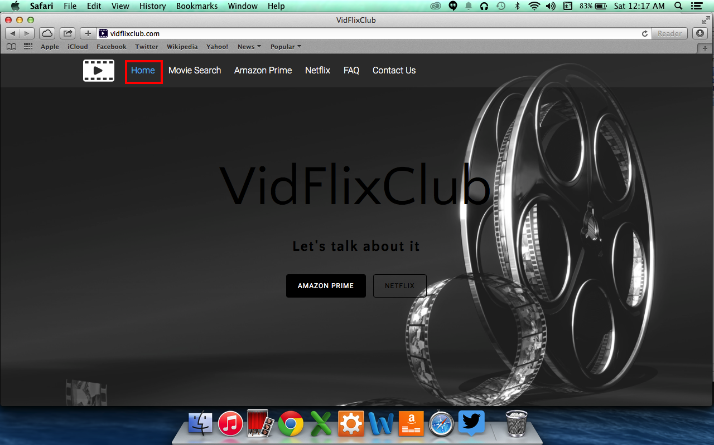

On this page you can do the following:

* Access any area of the website by clicking its link in the menu bar. The “Amazon Prime” and “Netflix” pages also have their own buttons in the middle of the page.
* Subscribe or unsubscribe to different categories of posts on the site (Figure 1.2).
* Search our movie database (Figure 1.2).
* View our VidFlixClub Calendar of Events (Figure 1.2).

### Figure 1.2

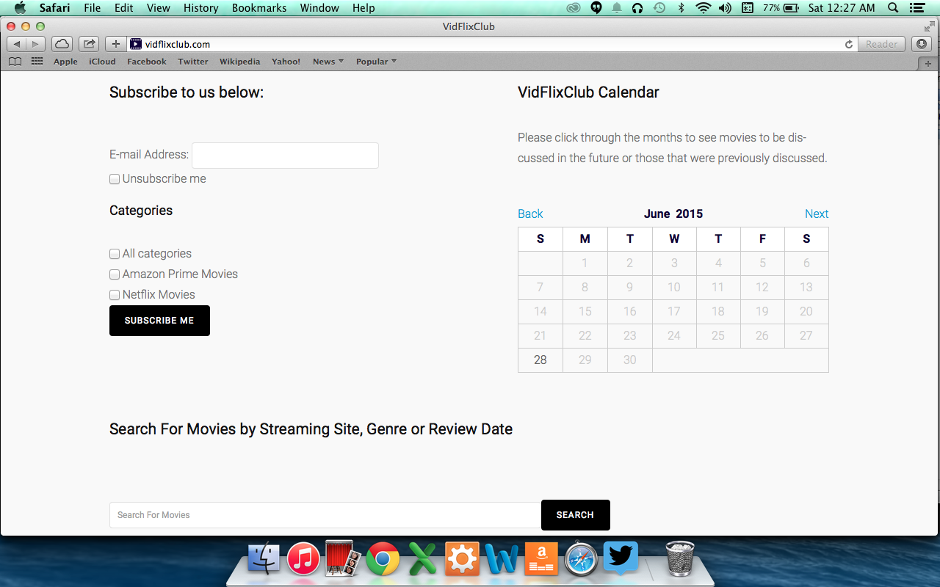

## Movie Search Page

The [Movie Search](http://vidflixclub.com/movie-search/) page (Figure 2) will allow users to search our movie database for movies watched or to be watched by the club. You can search by genre or streaming site. Once a search is done, you are able to see the movie (with link), week it was reviewed, genre, MPRS, duration, streaming site, and description.

### Figure 2

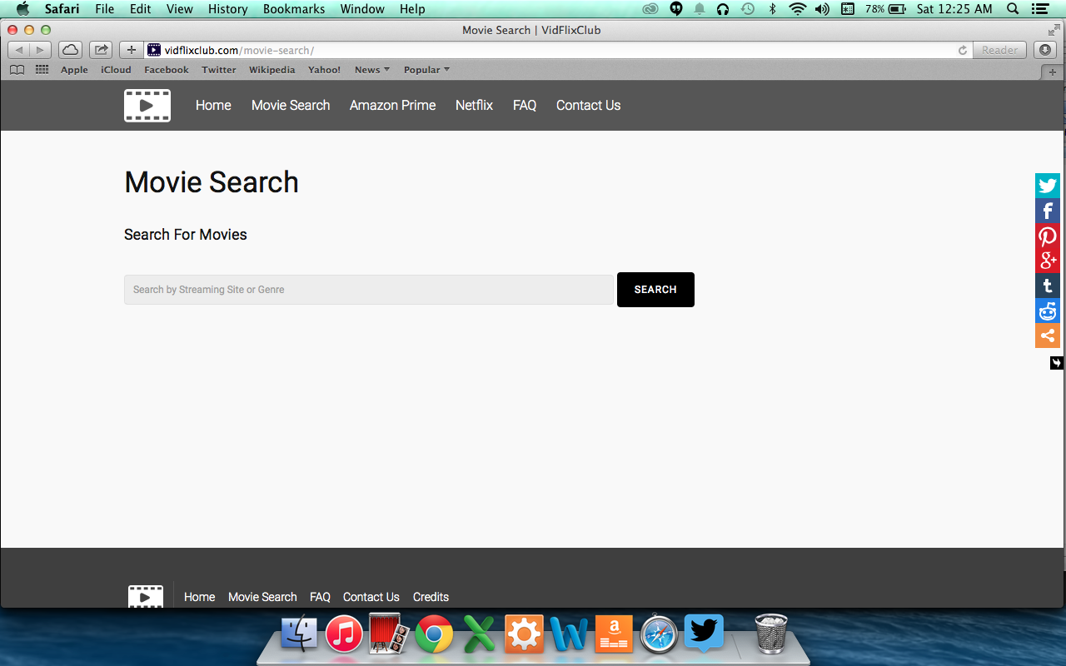

## Amazon Prime Page

The [Amazon Prime](http://vidflixclub.com/amazonprime/) page(Figure 3) lists all of the posts for movies that are on Amazon Prime. The movie posts are listed in the order in which they are discussed with the newest movie being listed first. If you would like to scroll through the list, please click one of the arrows that are highlighted in Figure 3.

### Figure 3

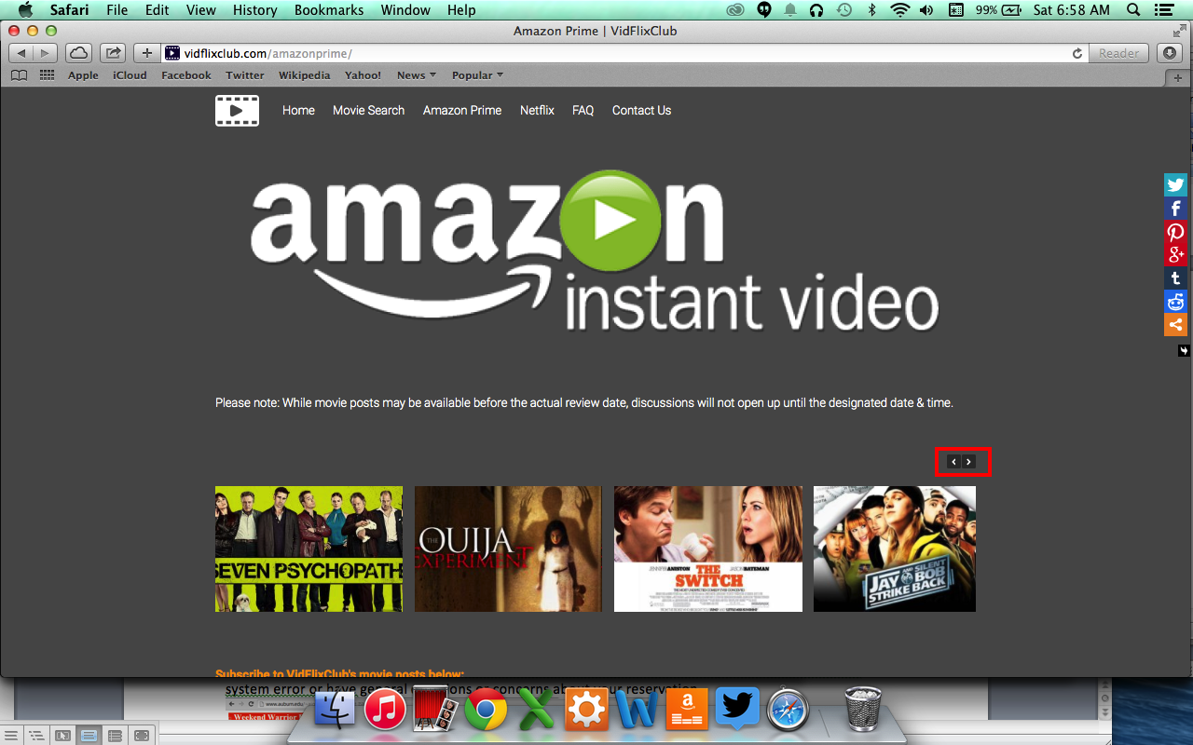

## Netflix Page

The [Netflix](http://vidflixclub.com/netflix-movies/) page(Figure 4) lists all of the posts for movies that are on Netflix. The movie posts are listed in the order in which they are discussed with the newest movie being listed first. If you would like to scroll through the list, please click one of the arrows that are highlighted in Figure 4.

### Figure 4

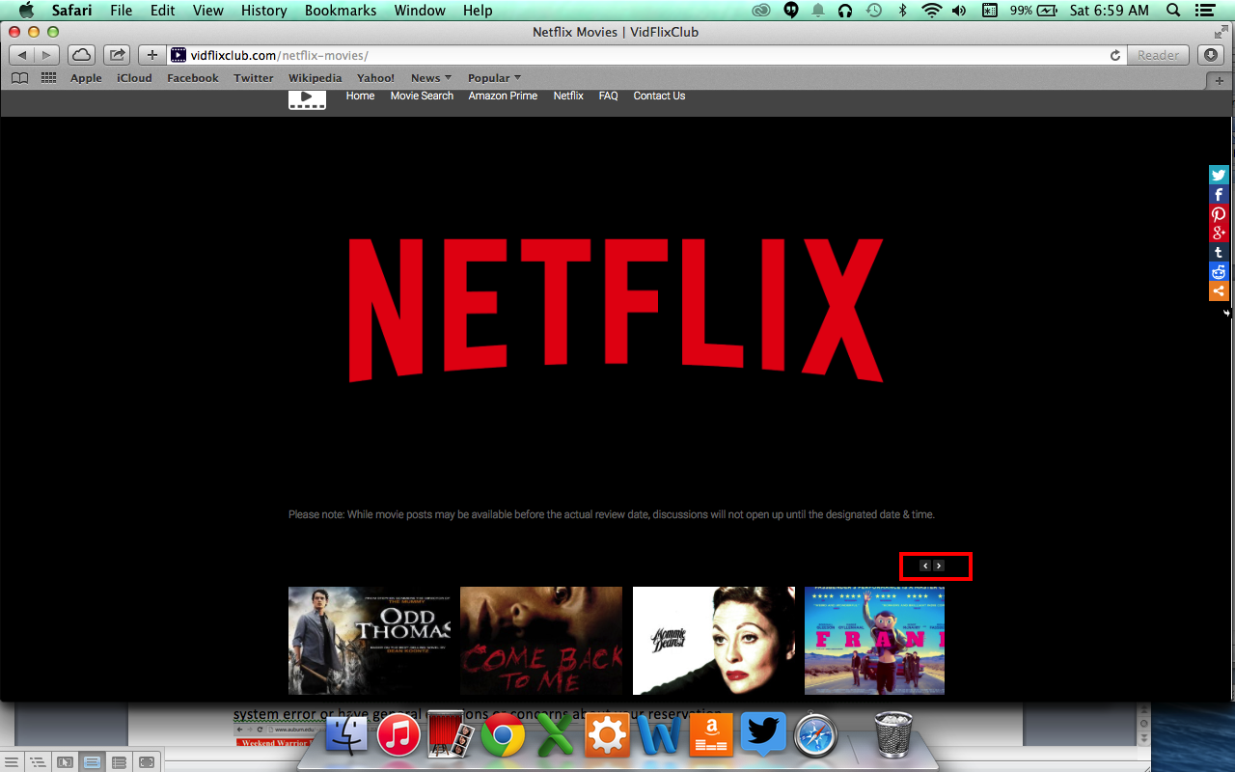

## FAQ Page

The [FAQ](http://vidflixclub.com/faq/) page (Figure 5) contains questions that may be frequently asked.

### Figure 5

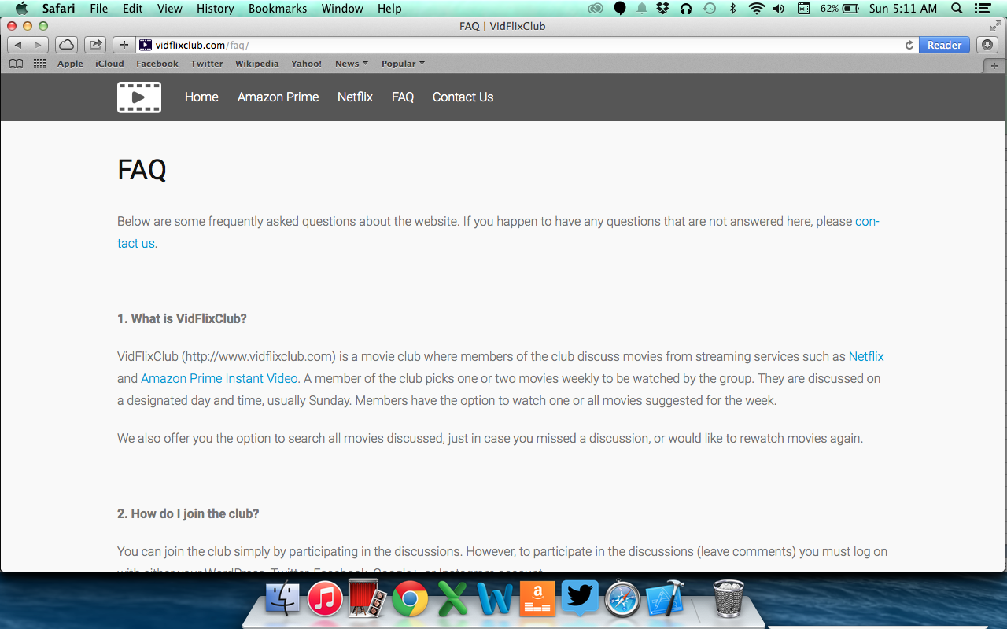

## Contact Us Page

The [Contact Us](http://vidflixclub.com/contact/) page is how you would get in contact with us if you have any questions. In the picture below (Figure 6), there are buttons that link you to the [Movie Suggestions](http://vidflixclub.com/contact/movie-suggestions/) and [Movie Deletions](http://vidflixclub.com/contact/movie-deletions/) pages, which will be explained later on in this document. There is also a form below (Figure 6.1) that for you to fill out if there are any questions that are not answered on the [FAQ](http://vidflixclub.com/faq/) page. Along with the form is a CAPTCHA field to help with spam. Type the letters that you see in the image into the field before hitting send.

### 

### Figure 6

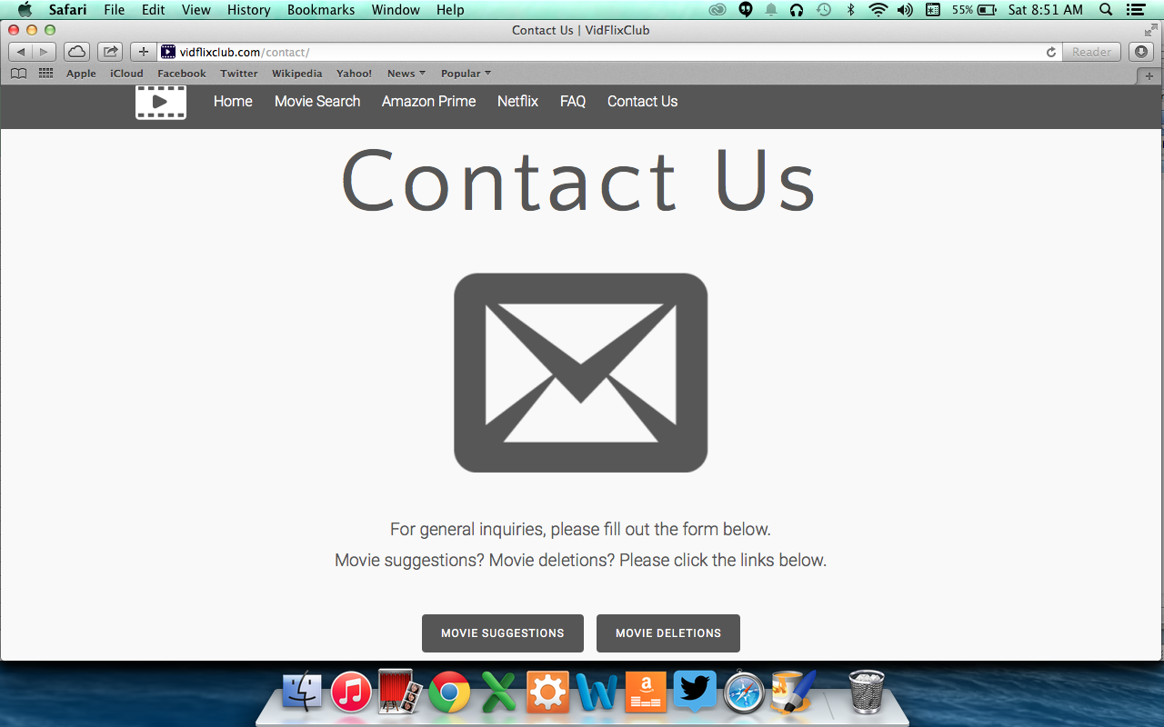

### Figure 6.1

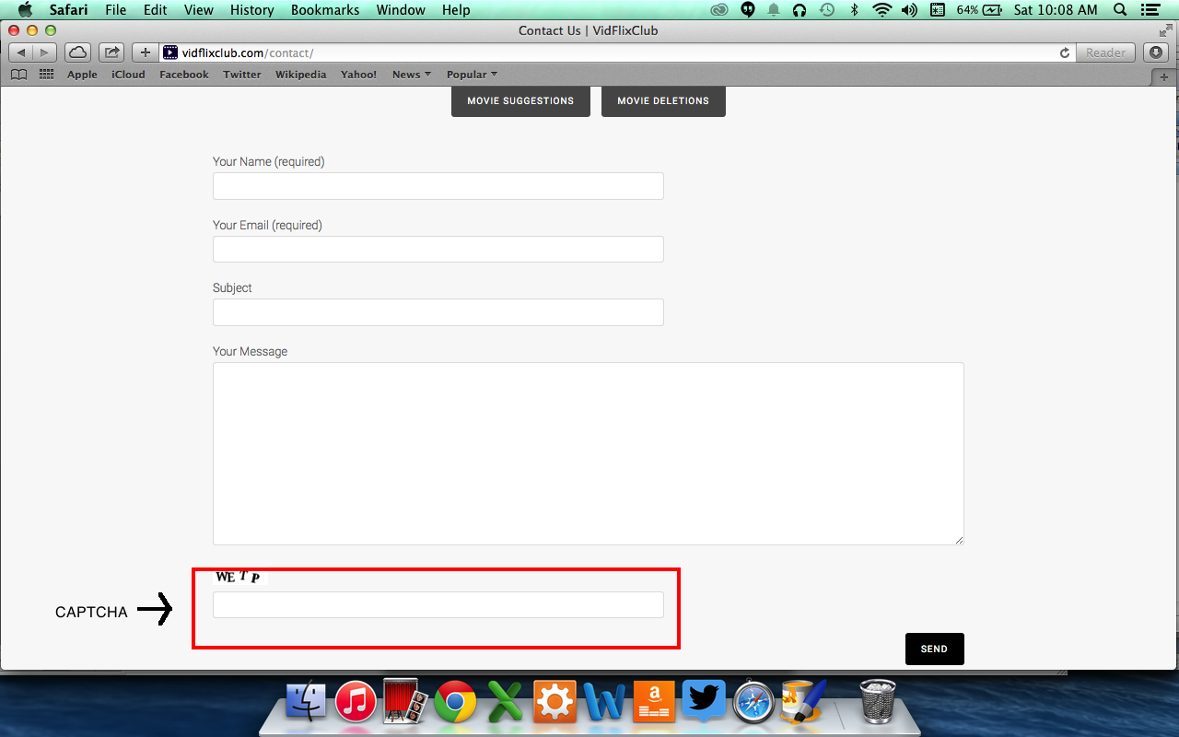

## Movie Suggestions Page

The [Movie Suggestions](http://vidflixclub.com/contact/movie-suggestions/) page (Figure 7) is where you would go if you wanted to suggest a movie for the group to watch. Please include the streaming site in which the movie is located when filling out the form. You will receive an email letting you know that we received your request and another one once the movie is added.

### 

### Figure 7

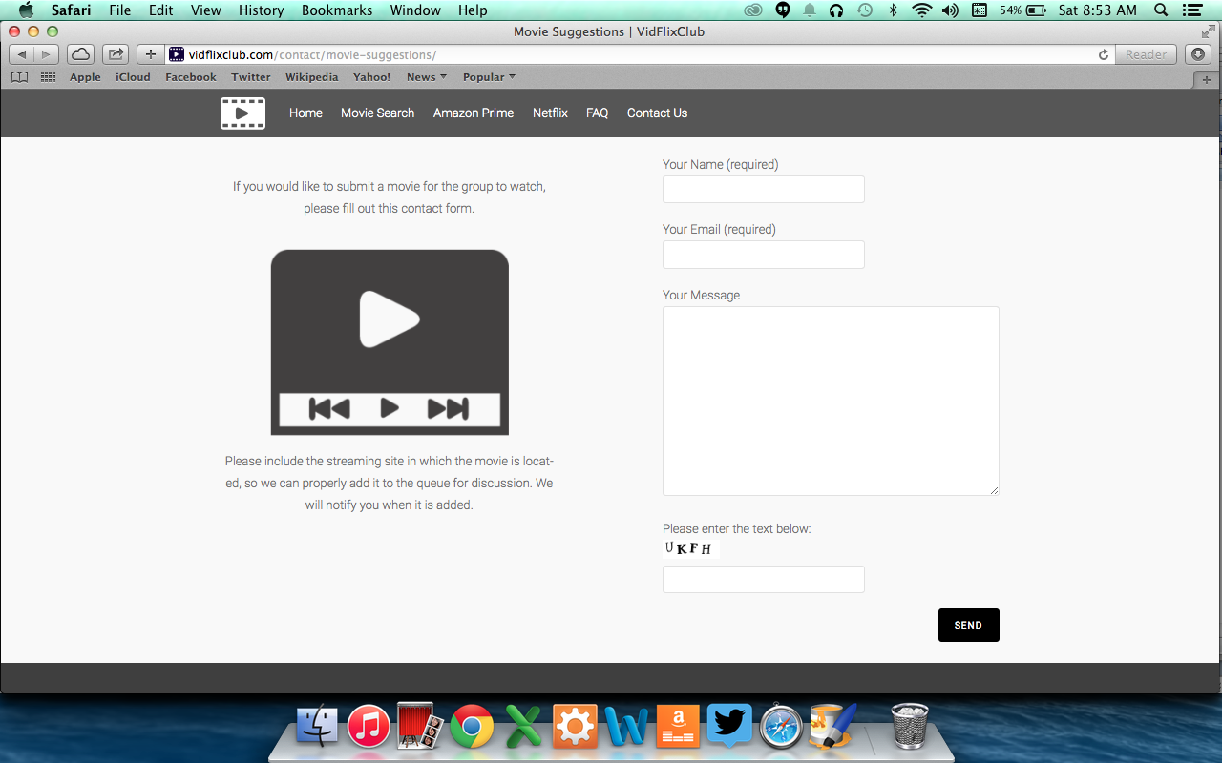

## Movie Deletions Page

The [Movie Deletions](http://vidflixclub.com/contact/movie-deletions/) page (Figure 8) is dedicated to helping us fix broken links and delete movies that may no longer be available on its respective streaming site. If you fill out the form on the page we will work to get the issue fixed for you.

### Figure 8

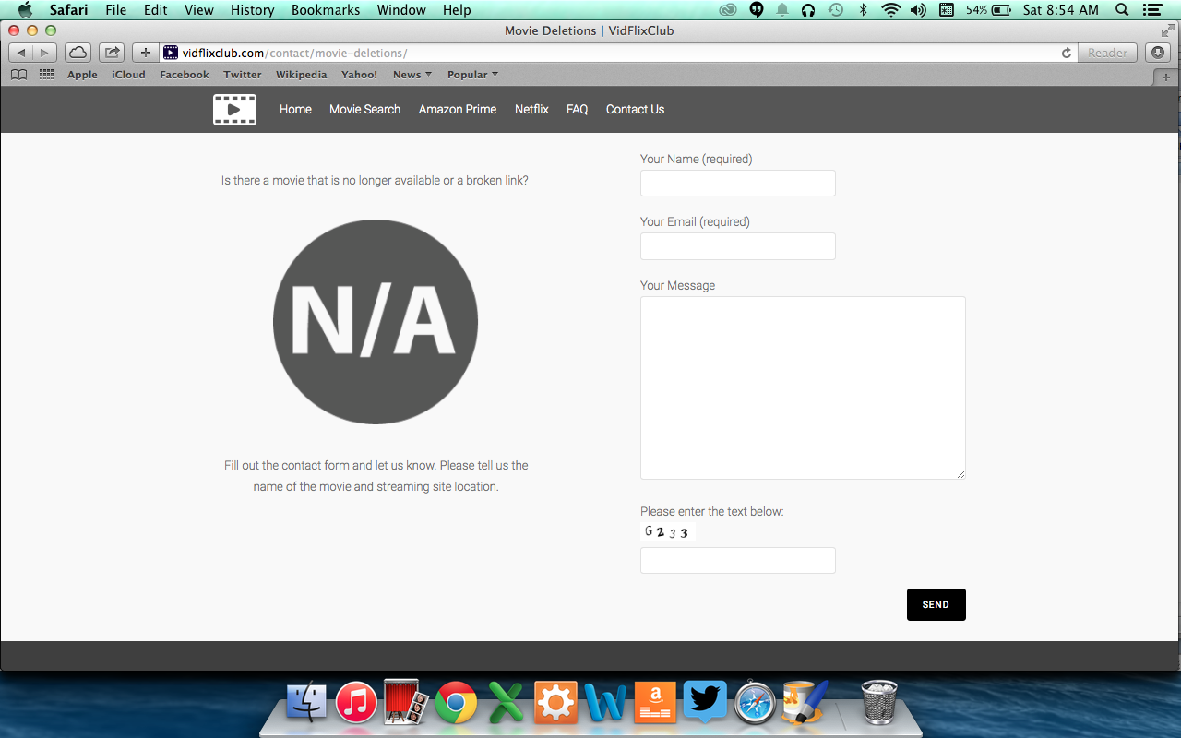

## Credits Page

The [Credits](http://vidflixclub.com/credits/) page (Figure 9) contains special credits and references that may have been used to create this site.

### 

### Figure 9

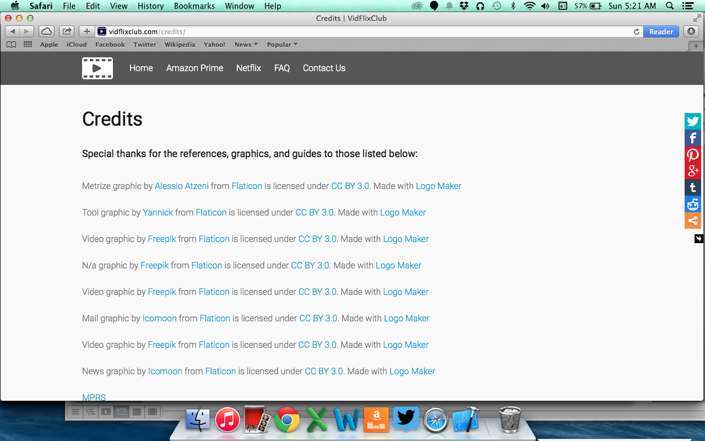

# Administration Functions

As the administrator of this website you will have access to the hosting space on Hostgator.com along with the Wordpress site that it is connected to. The Hostgator.com hosting space contains access to Cpanel, email, and databases. All of this is better explained in the Technological Details document. Below is an explanation of the functions allowed in Wordpress.

## Wordpress Login/Log Out

In order to access administrative functions on Wordpress, you must be logged in as the administrator. You can access the administrative login page by navigating to the admin page (<http://vidflixclub.com/wp-admin>). From there you will be redirected to the page (Figure 10) below where you will be instructed to login with your administrative credentials. To log out of admin (Figure 10.1), scroll over “Howdy *your username*”(1) and click the “Log out”link (2).

### Figure 10

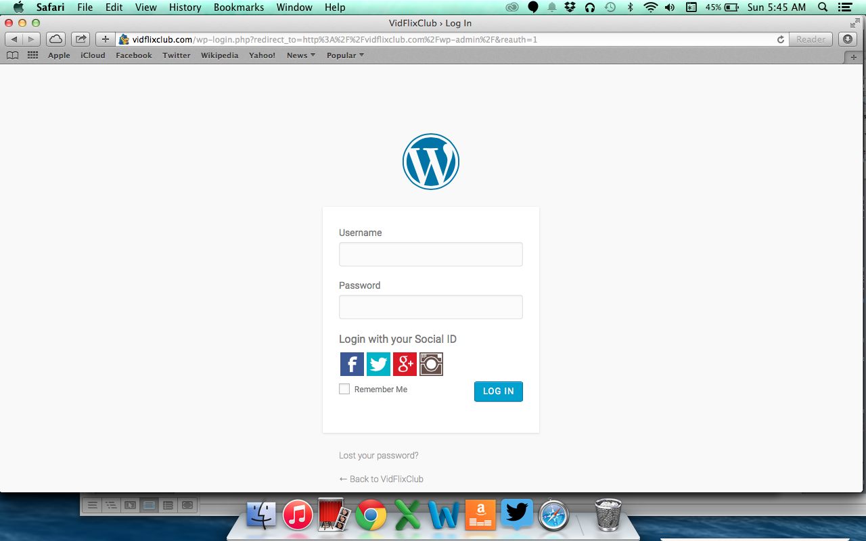

### Figure 10.1

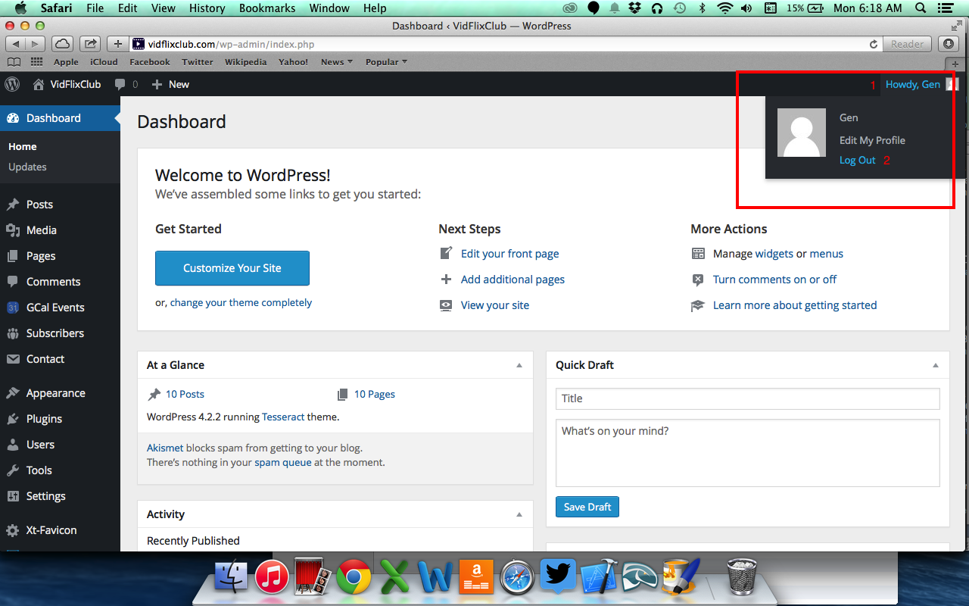

## WP Admin

Once you have logged in as an administrator you will have access to the background elements of the VidFlixClub website through Wordpress. Below are some basic pages that you will be able to access. Each contains a brief description of their use. *Note: Some features in the icon bar are actually plugins. More on those are in the VidFlixClub Technological Details document.*

### Dashboard

From the Dashboard page you have access to widgets, updates, menus and other basic things such as adding posts or pages to your website.

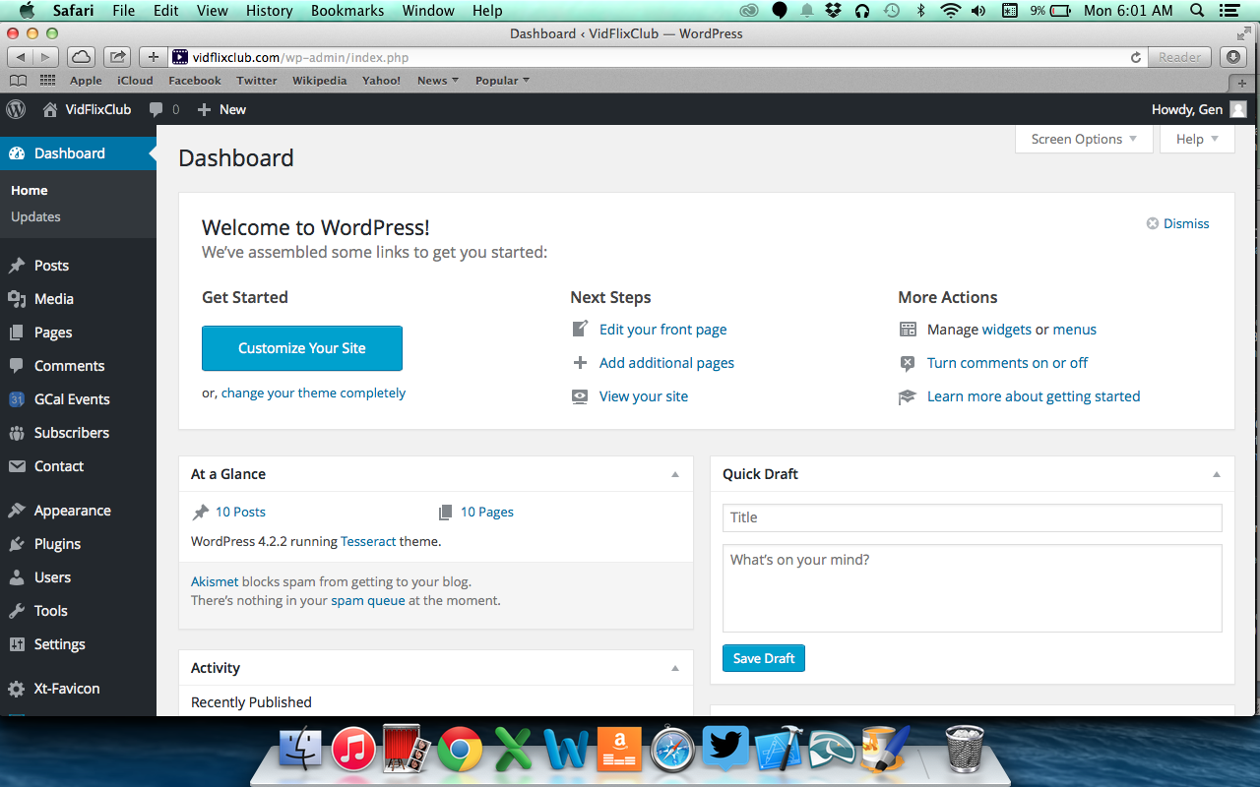

### Posts

From the Posts page you can add, edit, and delete posts and add categories and tags to those posts.

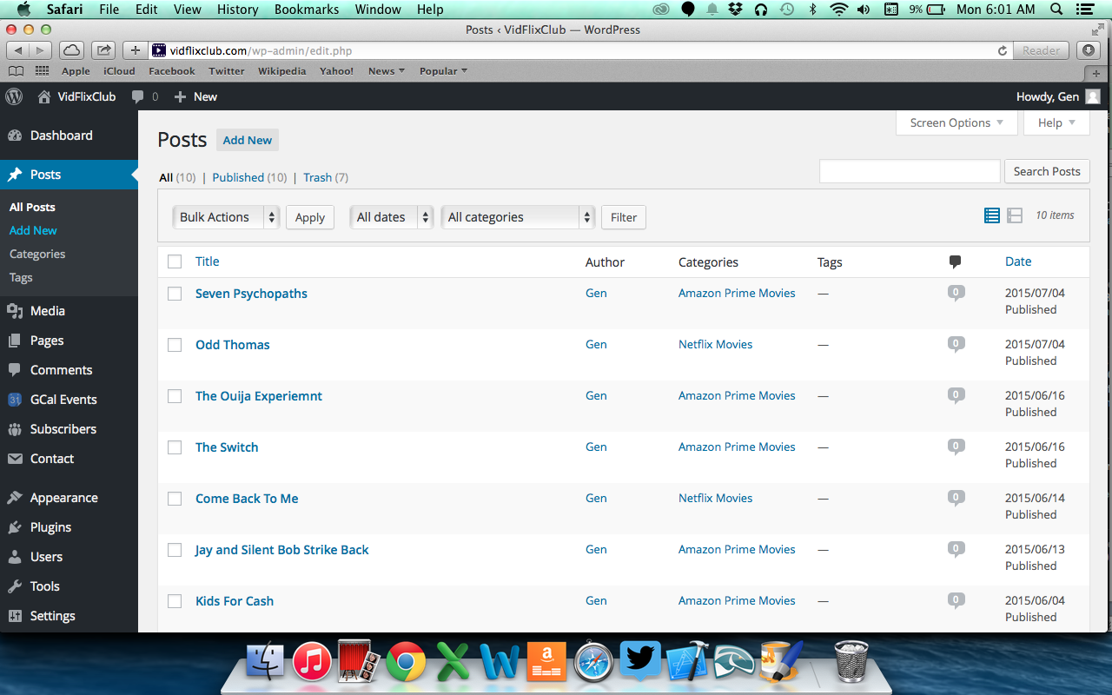

### Media

From the Media page you can add, edit, and delete all media that is to be used on your website. You can add images, audio, and video from this page.

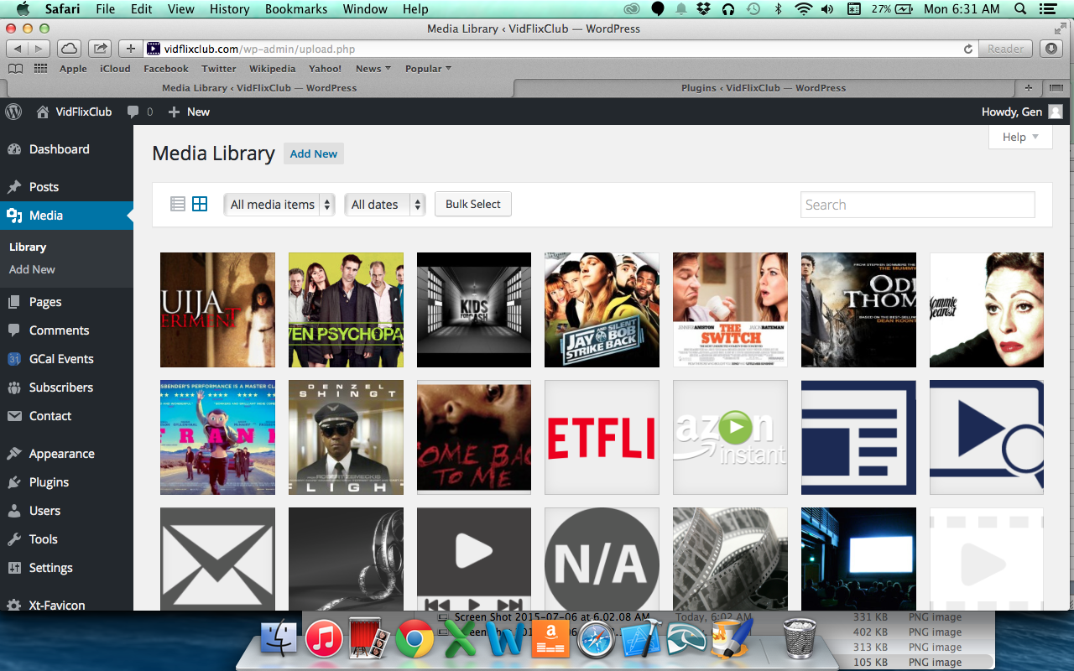

### Pages

The Pages page allows you to edit, delete and create pages. While Pages cannot be added in to categories, they are very flexible in the creation of your site.

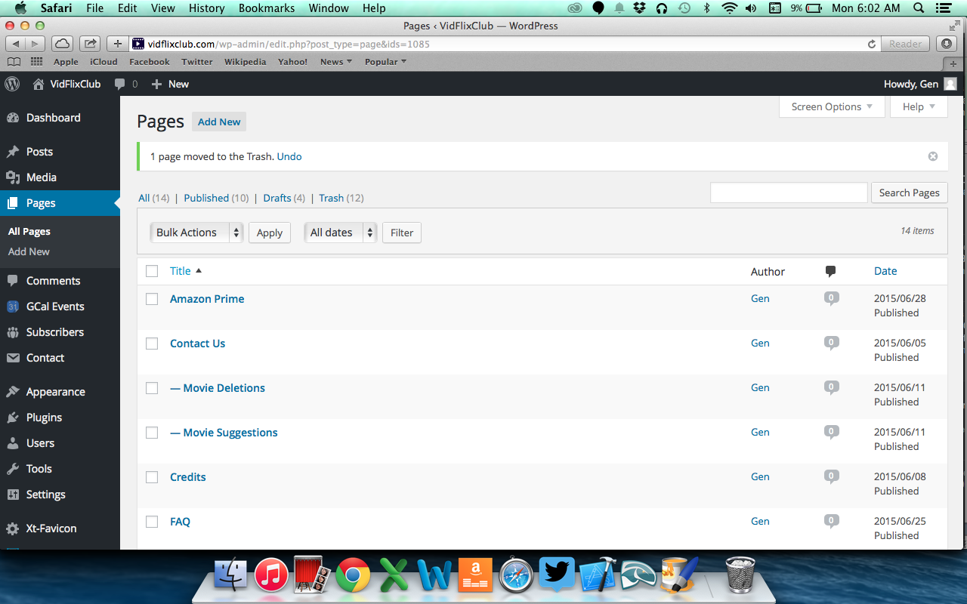

### Comments

In the Comments page you can monitor comments made by users. Here you can delete any spam or abusive comments.

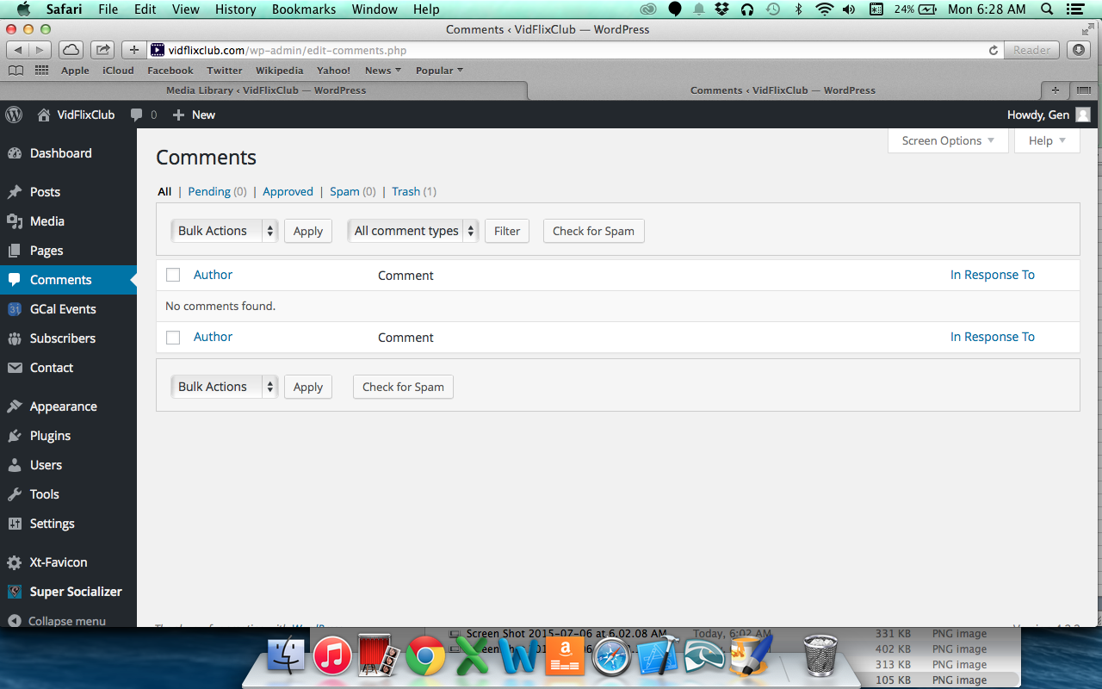

### Appearance & Themes

In Appearance & Themes you customize the general look of the website with themes and have the option of editing the menu, header, and background.

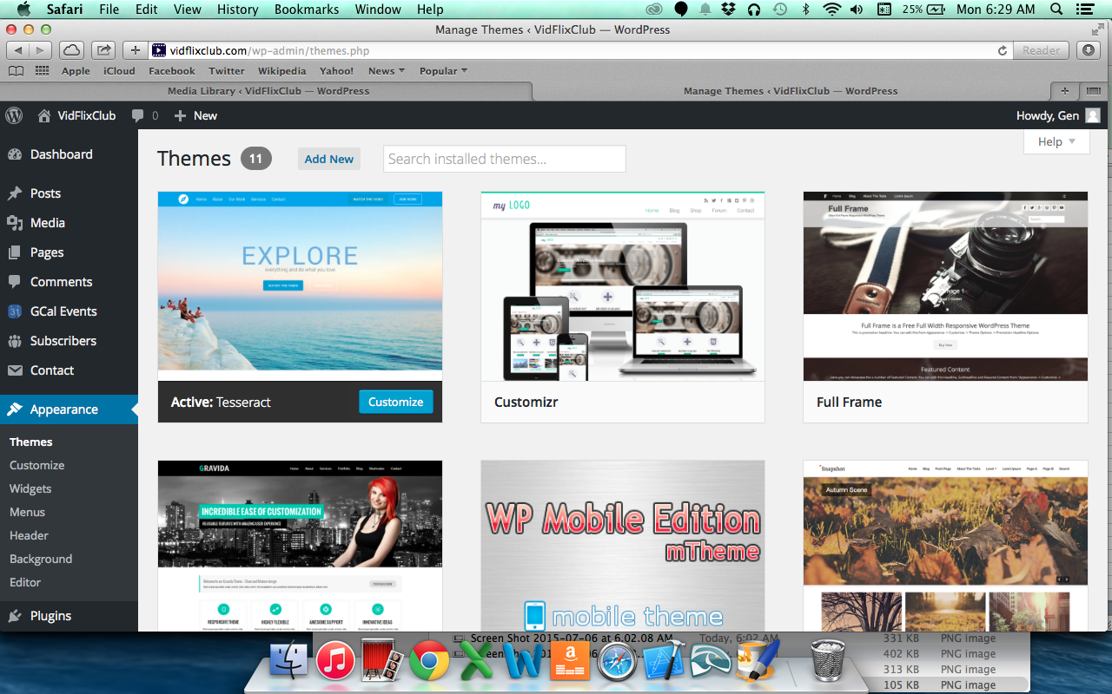

### Plugins

The Plugins page is where you access all plugins you want for your site. Here you can search, upload, install, activate, deactivate, edit, and delete plugins.

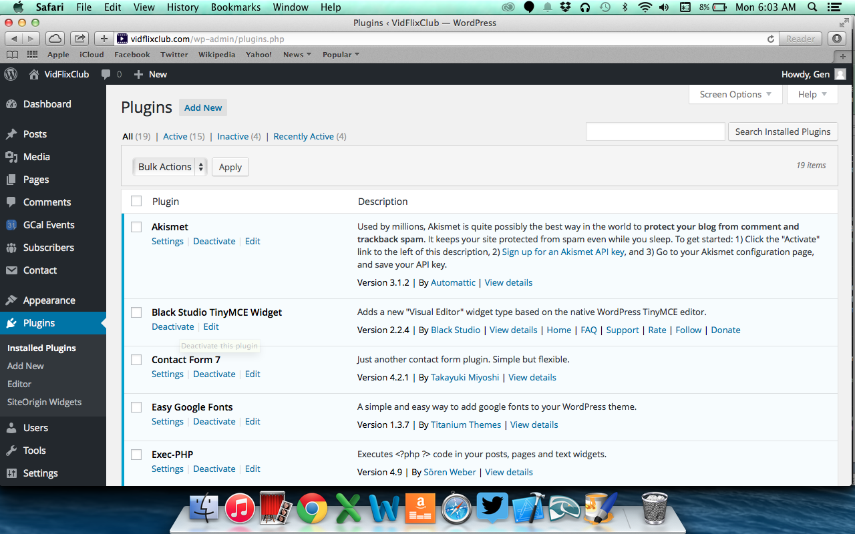

### Users

In the Users page you can add or delete users and change their roles on your website to a number of things that are listed in the dropdown box labeled, “Change role to…”.

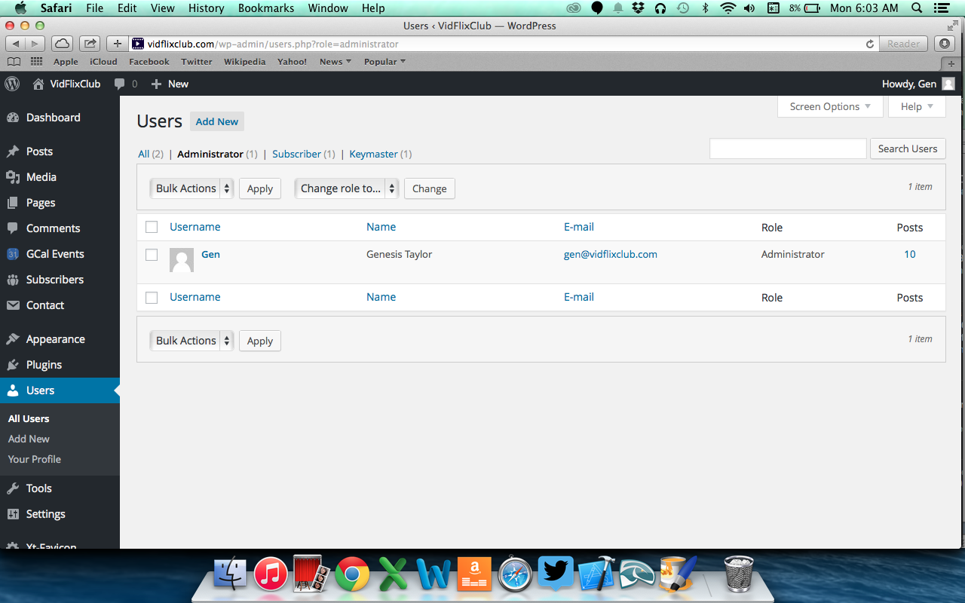

### Tools

The Tools Page lets you import posts from another Wordpress site on to yours.

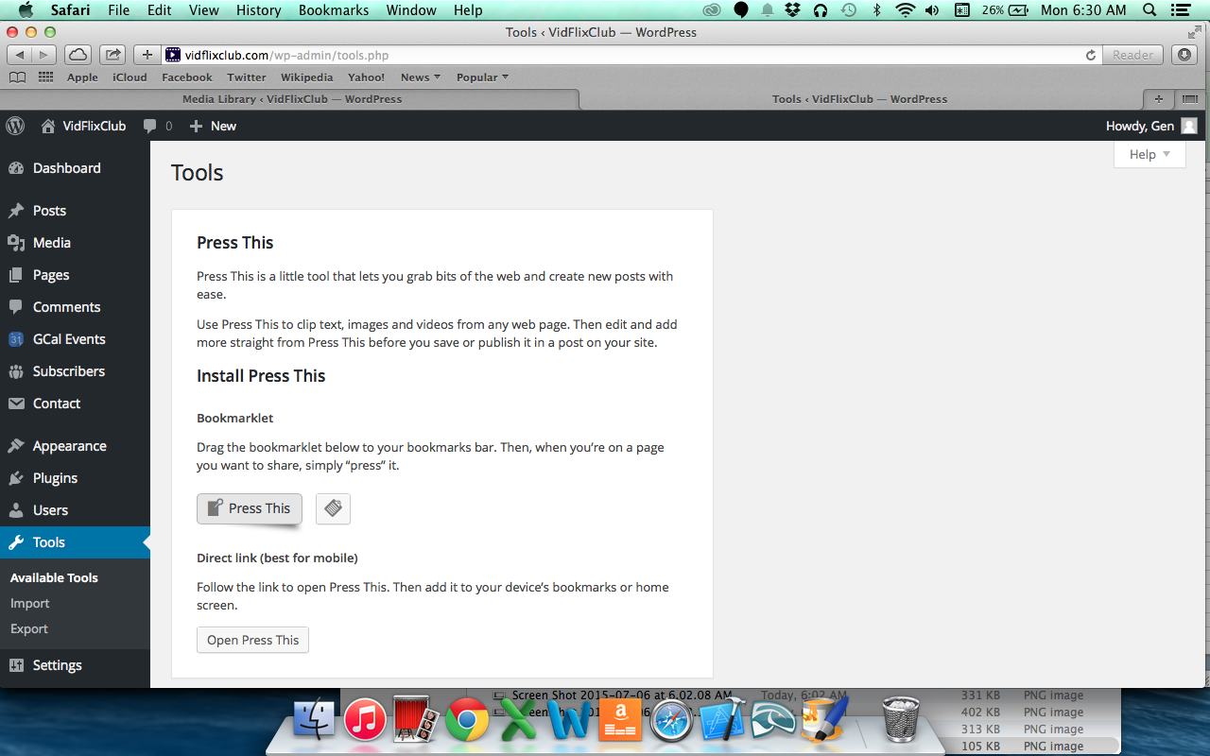

### Settings

The settings page allows you to control different areas on your website such as date and time, who can register for your site, what is the first page of your site, how many comments are allowed on a page, and how those comments are monitored.

